**MARKING GUIDE**

**GEOGRAPHY PAPER ONE**

**U.C.E NEREB NATIONAL MOCKS**

**OBJECTIVES:**

1. C 18. C
2. C 19. B
3. C 20. B
4. A 21. A
5. D 22. C
6. A 23. B
7. A 24. B
8. B 25. A
9. B 26. B
10. C 27. B
11. A 28. D
12. B 29. B
13. C 30. C
14. B
15. B
16. C
17. A

**MAP WORK**

**QN.1**

a (i) Manmade feature at 164510 is a dam

(ii) 207632

b. Average height of Aloi

Average height = Highest elevation + Lowest elevation

2

3878ft + 3400ft

2

Average height of Aloi is 3639ft

c. Cross section

on the graph paper

d. (i) Economic activities include;

- Settlement

- Trade

- fishing

- Pastoralist

(ii) Factors that have favored the activities;

* Presence of a vast land
* Relatively flat relief/topography
* Existence of rivers e.g R.Aloi
* Existence of transport routes

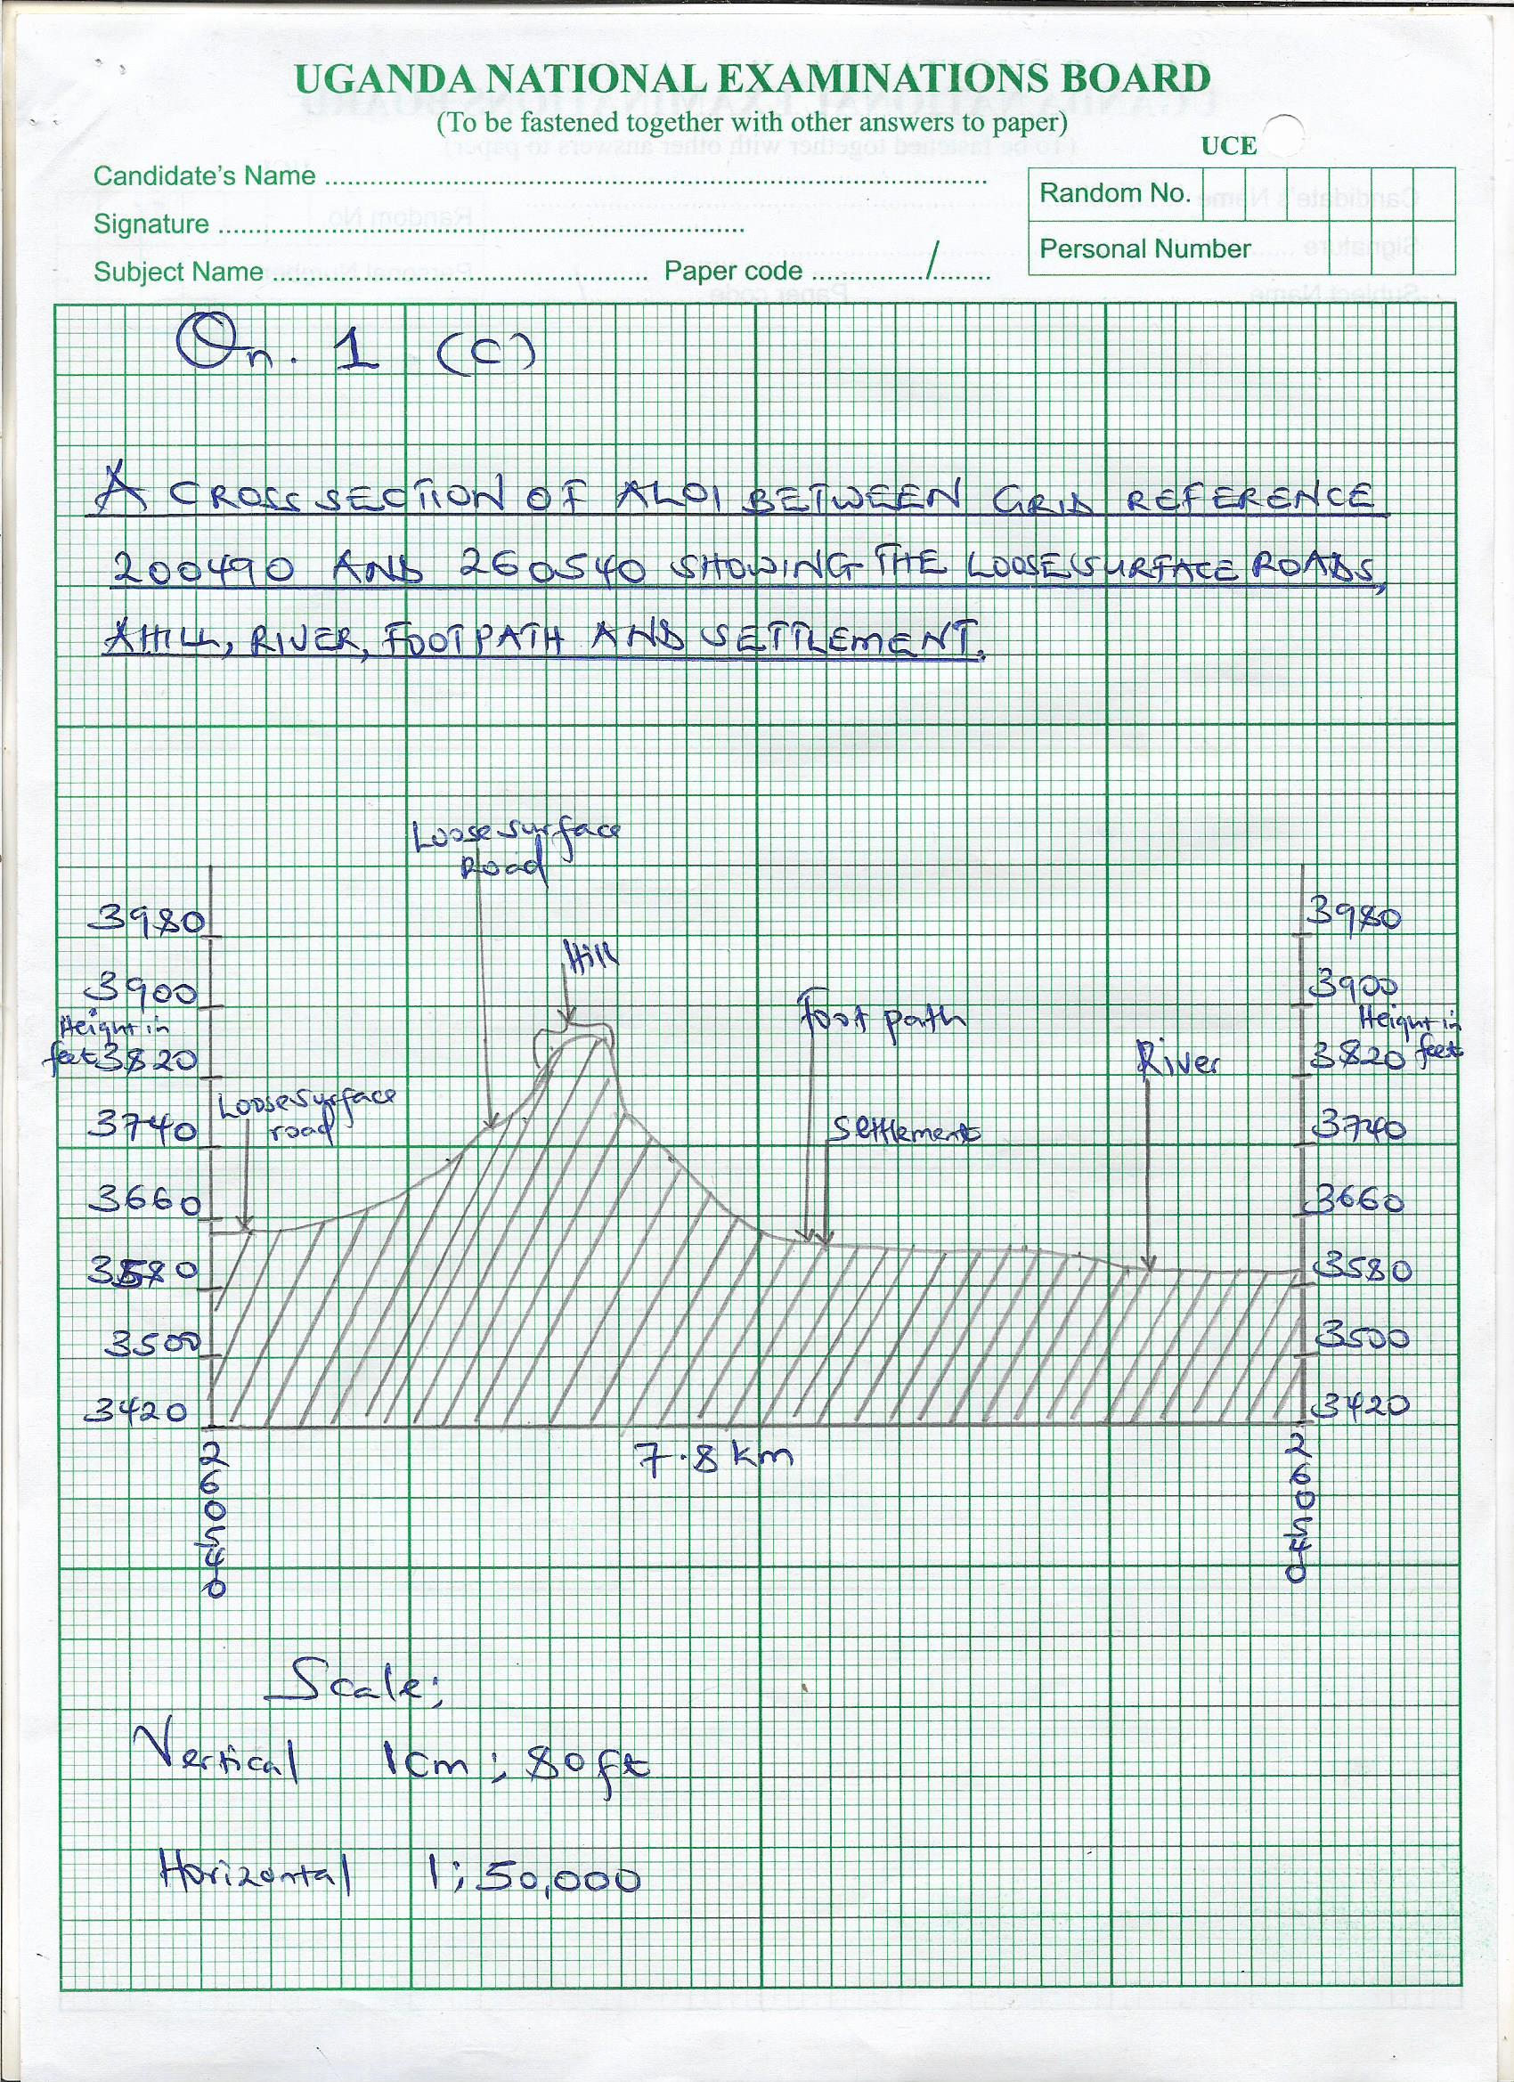

**QN.2**

1. **A LANDSAPE SKETCH OF THE AREA SHOWN ON THE PHOTOGRAPH SHOWING A RIDGE, VEGETATION TYPES, JETTY, TELECOM MAST AND WATER BODY**

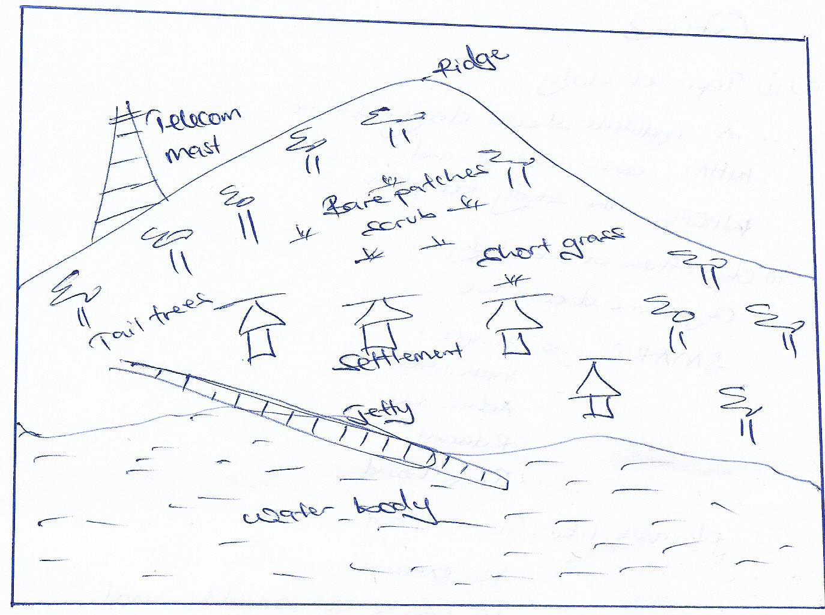

1. Fishing
2. (i) Factors that have favored the activity;

* Existence of a water body as seen in the foreground
* Adequate capital evidenced by boats in the middle ground
* Skilled labour as evidenced in the middle ground
* Improved communication evidenced by a telecom mast in the left back ground

(ii) Problems faced by people;

* Congestion
* Easy spread of diseases
* Water borne diseases
* Water accidents/drowning
* Presence of a water body as evidenced in the photograph

1. Kasenyi fish landing site

**QN. 3**

1. (i) Topic of study

A candidate should clearly state;

* **WHAT** was studied and
* **WHERE** the study took place

(ii) Objectives of the study

Objectives should be

**SMART** i.e.;

* Simple
* Measurable
* Achievable
* Relevant
* Time bound

**Phrases like;**

* To find out
* To examine
* To assess e.t.c should be used

**Phrases like;**

* To know
* To appreciate
* To feel e.t.c should be used

1. An annotated relief section of an area studied should clearly be shown.

* The place local names of features
* The starting and end point of a transect should be marked
* Features should all sit on the cross section line
* Arrow shouldn’t be left hanging

1. **Follow up activities include;**

* Presentation of data
* Analyzing
* Polishing sketches
* Drawing conclusions
* Making recommendations

1. **Skills gained;**

* Skill of observation while using the observation method
* Skill of drawing sketches while using the recording method
* Skill of interviewing while using the interviewing method
* Skill of measuring while using the measurement method

**SECTION B**

**QN. 4**

a)

(i) Mountains; A. Mt. Kilimanjaro

B. Mt. Muhavura

(ii) Lakes; C. Lake Eyasi

D. Lake Rukwa

(iii) Ports 1. Kigoma

2. Mwanza

b) Lake Rukwa;

Lake Rukwa is a Graben lake which was formed as a result of faulting. Tension forces pulled the earth’s block in opposite directions leading to formation of a rift valley. This was followed by secondary faulting and secondary sinking of part of the rift valley floor to a rift valley lake as illustrated below;

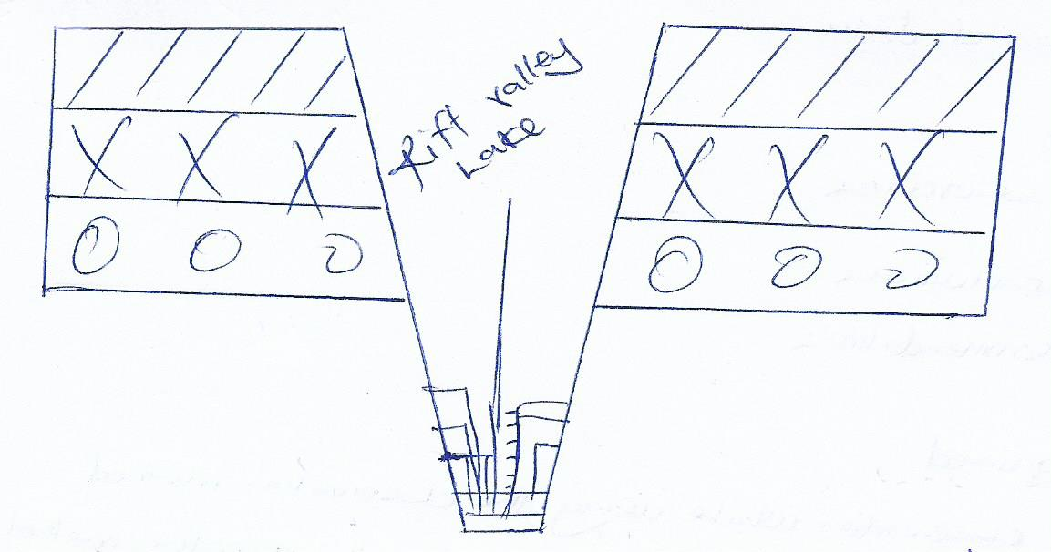

**Benefits of lakes include the following;**

c) They are a source of minerals examples,

- Salt from Lake Katwe, Soda ash from L.Magadi

- Lakes help in rainfall formation that is convectional rainfall

- They attract tourists who bring in foreign exchange

- Lakes are a source of fish which contains proteins good for human health

- Some lake like L.Victoria are used for navigation

d) **Problems faced by people living in areas near lakes;**

- Water accidents like drowning

- Attacks from dangerous aquatic animals

- Easy spread of water borne diseases like Bilharzias e.t.c

- flooding especially during rainy season

**QN. 5 (a)**

**A SKETCH MAP OF EAST AFRICA SHOWING INDUSTRIAL**

**CENTERS, RIVERS AND MOUNTAINS.**

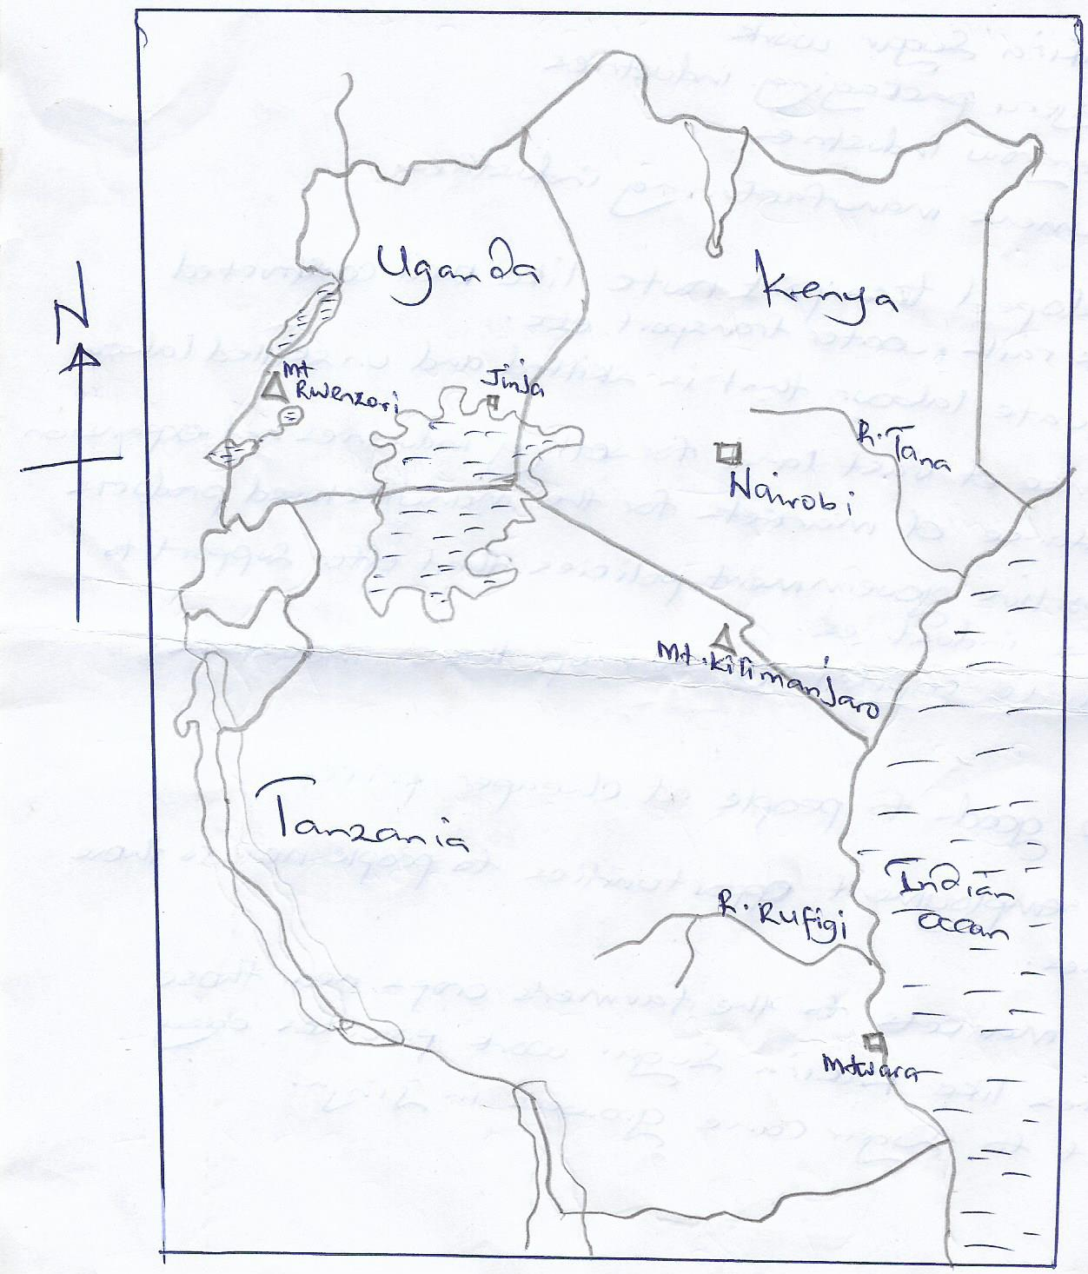

(08 MARKS)

(b) (i) Nairobi;

- Crown paints

- Kings plastics industries, Kartasi industries, Manji food industries limited Jinja

- Kakira sugar work

- Najeru packaging industries

- Kengrow industries

- Lumens manufacturing industries.

(ii) Developed transport route like well constructed roads, rails, water transport e.t.c

* Adequate labour that is skilled and unskilled labour
* Presence of vast land for setting industries and expansion
* Existence of markets for the manufactured products
* Supportive government policies that offer support to those industries.
* Adequate capital to set up these industries

(c)- provide goods to people at cheaper prices

- provide employment opportunities to people near to those industries.

- create markets to the farmer’s crops near those industries like kakira sugar work

provides easy market to sugar cane grower in Jinja

**QN. 6**

1. On the graph paper
2. (i) Percentage of agricultural exports

Agricultural exports are;

Coffee 270

Tea 54

Maize 120

**Total 444**

444 x 100%

509

87.2%

= 87%

(ii) Percentage of mineral exports

Mineral exports include

Sand = 25

Copper 40

**Total 65**

65 x 100%

509

12.7%

~ 13%

1. **Problems facing the export sector in Uganda include;**

* pest and diseases the crops grown
* Limited markets
* Undeveloped transport routes like muddy and poor dusty roads
* The delay exports to the market centers
* Limited skilled labour to help in growing and processing of the exports.
* Unsupportive government policies

1. Solutions to the problems in (c) above

* Regular spraying with pesticides should be done to prevent pests and diseases
* Market surveys and research should be one in order to get easy markets for the exports.
* The government should support people to export to other countries like setting up minimized policies on exports.
* Hiring of skilled labour to work on exports
* Improving of transport routes like constructing good roads to easy transport of good (exports) to market centers.

**QN. 7**

1. (i) Urban center A. Nairobi

B.

(ii) Transport route C. Mombasa, Nairobi – Kisumu Railway

(iii) Water body 1 Lake Turkan

(iv) Ports D Kisumu

E Mombasa

1. **Factors that have favored the development of ports in East Africa include;**

* Well sheltered natural harbours
* Modern/advanced technology
* Strategic location of East Africa

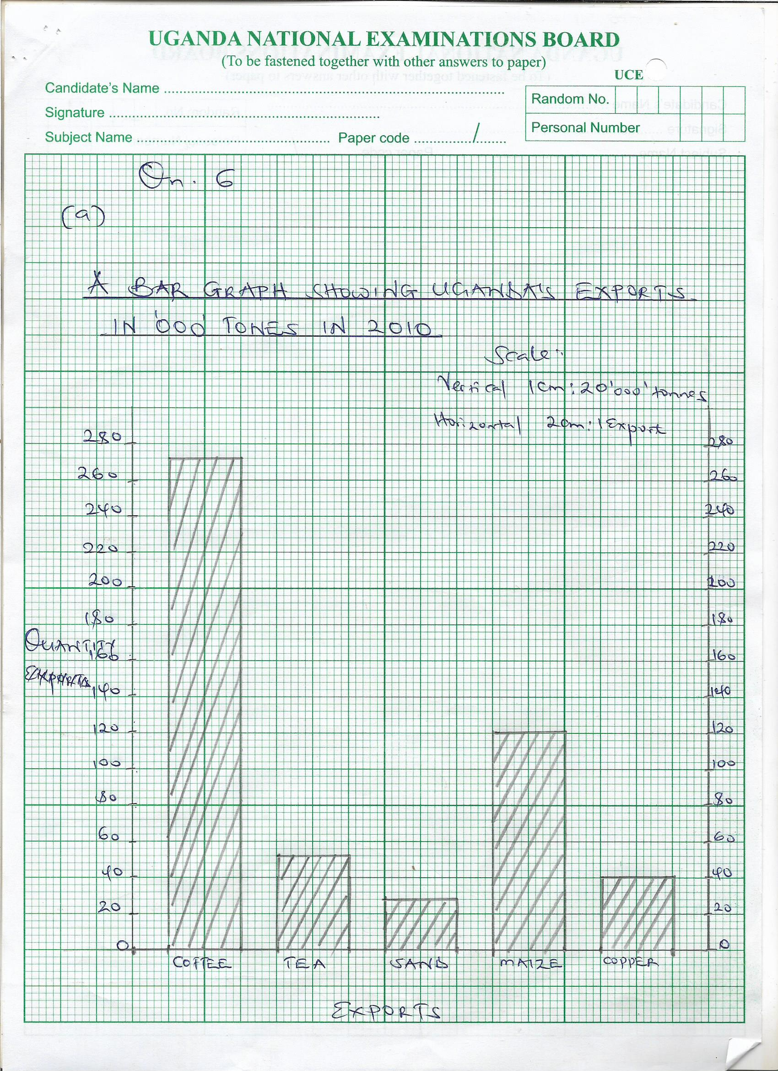

b.- Provides markets to people’s goods

- handles exports and imports

- create employment opportunities for people like cargo handlers e.t.c

- Act as recreational enters where people enjoy their leisure time.

- promoted trade in East Africa countries like Uganda, Kenya, Tanzania

- promoted unity among people of East Africa

d) Congestion

- Easy spread of diseases

- Decline in morals where activities that lead o decline of orals are being practiced

like prostitution, smoking, alcoholism, e.t.c

* Separation of families because people especially men who tend to go to these ports to trade do not go back to their families